**Module 2: Scene Generation**

# **Tab 1: Objective**

The objective of this project is to develop a Synthetic Aerial Image Generation GUI that allows users to upload TIFF images and apply various transformations using camera intrinsic and extrinsic parameters. The project aims to provide an interactive platform for analyzing aerial images with a realistic perspective transformation using Three.js.

**Tab 2: Science**

**1. Coordinate Frames and Transformations**

The process of synthetic aerial image generation involves multiple coordinate frames:

* **Inertial Frame** (Earth-Fixed): (Xi, Yi, Zi) is a global reference frame fixed on the Earth's surface.
* **Gimbal Frame**: (X g, Y g, Z g) originates at the gimbal's centre of rotation, with Z g pointing along the optical axis.
* **Inertial to gimbal Frame Transformation**

The transformation matrix for converting inertial coordinates to gimbal coordinates is

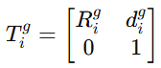

Where:

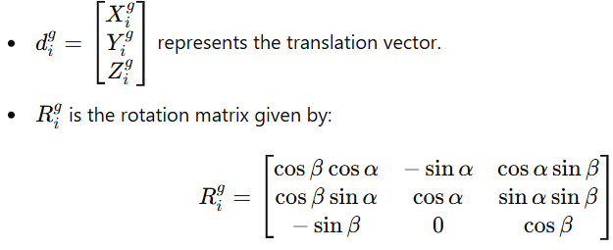

where α\alphaα is the tilt angle and β\betaβ is the pan angle.

* **Gimbal to camera Frame Transformation**

The transformation from the gimbal frame to the camera frame is given by:

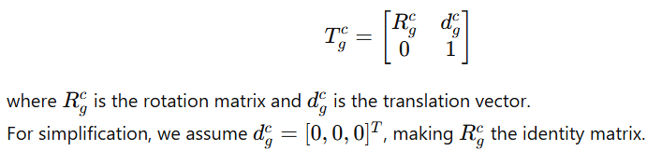

* **Camera Frame**: (X **c**, Y **c**, Z c) is cantered at the optical centre of the camera with Z c along the optical axis.
* **Image Frame**: Defined in pixels (x i p, y i p) and meters (x i m, y i m), measured from the camera's principal point.

**2.Camera Projection Model**

A perspective camera projects a 3D object point p obj = [p x, p y, p z, 1] T onto a 2D image point q = [x i p, y i p, 1] T.

Using similar triangles:

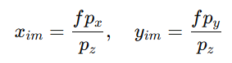

Where f is focal length of the camera.

The image coordinate transformation is given by:



Where:

* C is the camera calibration matrix

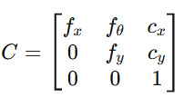

* A is a depth-dependent scaling matrix

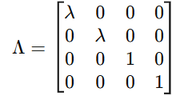



**3. Pixel to world coordinate Transformation**

The world coordinate corresponding to an image pixel is given by:



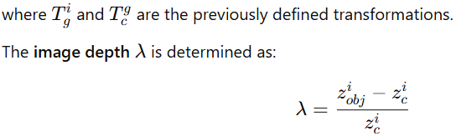

**4. Synthetic Image Generation Algorithm**

For each pixel in the synthetic image:

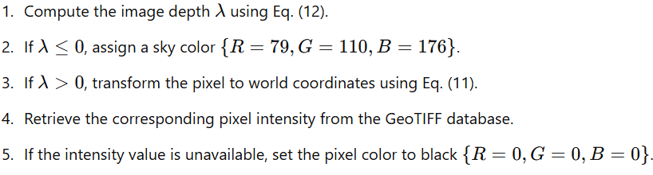

**Tab 3: Significance**

* **Improved Image Analysis:** Enables researchers and professionals to manipulate aerial images with high precision.
* **Educational Value:** Provides insights into photogrammetry and 3D image transformations.
* **Real-world Applications:** Used in geospatial analysis, urban planning, and defence applications.
* **Customizable UI:** Users can modify various parameters to simulate real-world aerial imaging scenarios.

**Tab 4: Description**

**1. System Overview**

The system consists of a web-based GUI where users can upload TIFF images and modify them using camera parameters.

**2. Key Features**

* TIFF file upload and processing
* Camera intrinsic parameter adjustment (Focal length, Pixel size, Image dimensions)
* Camera extrinsic parameter adjustment (Latitude, Longitude, Altitude, Pan, Tilt)
* 3D rendering using Three.js
* Exporting the processed image

**3. Technologies Used**

* **Front-end:** HTML, CSS, JavaScript
* **Libraries:** Three.js, TIFF.js
* **Rendering:** WebGL-based image visualization

**4. Workflow**

1. User uploads a TIFF image.
2. System extracts image data and applies transformations.
3. 3D rendering of the image is displayed based on the given camera parameters.
4. User can fine-tune the parameters and export the final image.

**OUTPUT:**

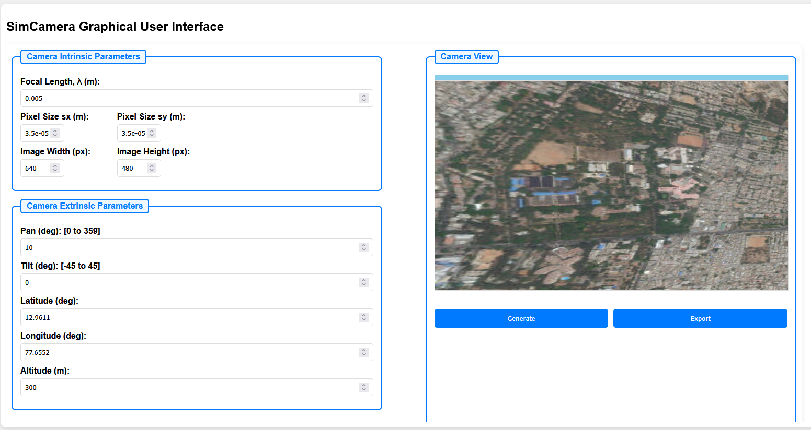

**Fig:1**

**Tab 5: Quiz**

1. **What is the purpose of this project?**
   * A) To generate aerial images
   * B) To edit normal photos
   * C) To create animations
   * D) To compress images
   * **Answer:** A
2. **Which technology is used for 3D rendering in this project?**
   * A) OpenGL
   * B) Three.js
   * C) DirectX
   * D) WebGL
   * **Answer:** B
3. **What type of image format is supported for input?**
   * A) PNG
   * B) TIFF
   * C) JPG
   * D) BMP
   * **Answer:** B
4. **Which parameter determines the altitude of the camera?**
   * A) Pixel size
   * B) Focal length
   * C) Latitude
   * D) Altitude
   * **Answer:** D
5. **What does the tilt parameter control?**
   * A) Rotation around the horizontal axis
   * B) Rotation around the vertical axis
   * C) Zoom level
   * D) Color balance
   * **Answer:** A
6. **Which JavaScript library is used to read TIFF images?**
   * A) Three.js
   * B) TIFF.js
   * C) Fabric.js
   * D) Chart.js
   * **Answer:** B
7. **What is the function of the focal length parameter?**
   * A) Determines the field of view
   * B) Adjusts the brightness of the image
   * C) Changes the image resolution
   * D) Controls contrast
   * **Answer:** A
8. **What is the background color of the rendered canvas in this project?**
   * A) White
   * B) Red
   * C) Blue
   * D) Green
   * **Answer:** C
9. **Which feature allows exporting the final image?**
   * A) Save to TIFF
   * B) Export button
   * C) Print function
   * D) Download plugin
   * **Answer:** B
10. **What is the main application of this project?**

* A) Graphic design
* B) Geospatial analysis and remote sensing
* C) Social media editing
* D) Mobile photography
* **Answer:** B